Vitalyst Health Foundation

Improving well-being in Arizona by addressing root causes and broader issues that affect health.

From Health Care to Health. For nearly 25 years, Vitalyst has served Arizona as a catalyst for community health and vitality. Established in 1996 following the sale of St. Luke’s Health System to a for-profit corporation, the foundation operated as St. Luke’s Charitable Health Trust (1996-1999) and St. Luke’s Health Initiatives (2000-2016).

Today, Vitalyst Health Foundation is an independent, non-partisan public foundation that has invested more than $100 million and established itself as a key thought leader, convener and catalyst of key initiatives – ranging from statewide health policy and systems to development of local community gardens.

Our Vision. All individuals and communities in Arizona are healthy and resilient.

Our Mission. To connect, support and inform efforts to improve the health of individuals and communities in Arizona.

Our Goals:
- Improve access to care and insurance coverage.
- Advance community policies and practices that result in healthy communities.
- Increase the capacity and effectiveness of community-based leaders, organizations
and coalitions.
- Cultivate collaborations and innovations that leverage the Elements of a Healthy
Community.
- Increase civic participation for inclusive decision-making to advance health equity.

Vitality + Catalyst = Vitalyst. The pursuit of our mission changed us over time, as any good journey should. Our work expanded beyond traditional boundaries of health care. Relationships, discoveries and learnings transformed us and crystallized an identity. Research not only confirmed that identity, it also affirmed the community’s view of our foundation as working towards the purpose of community vitality by consistently and effectively serving as a community health catalyst. We brought the two words together and became Vitalyst Health Foundation in March 2016.
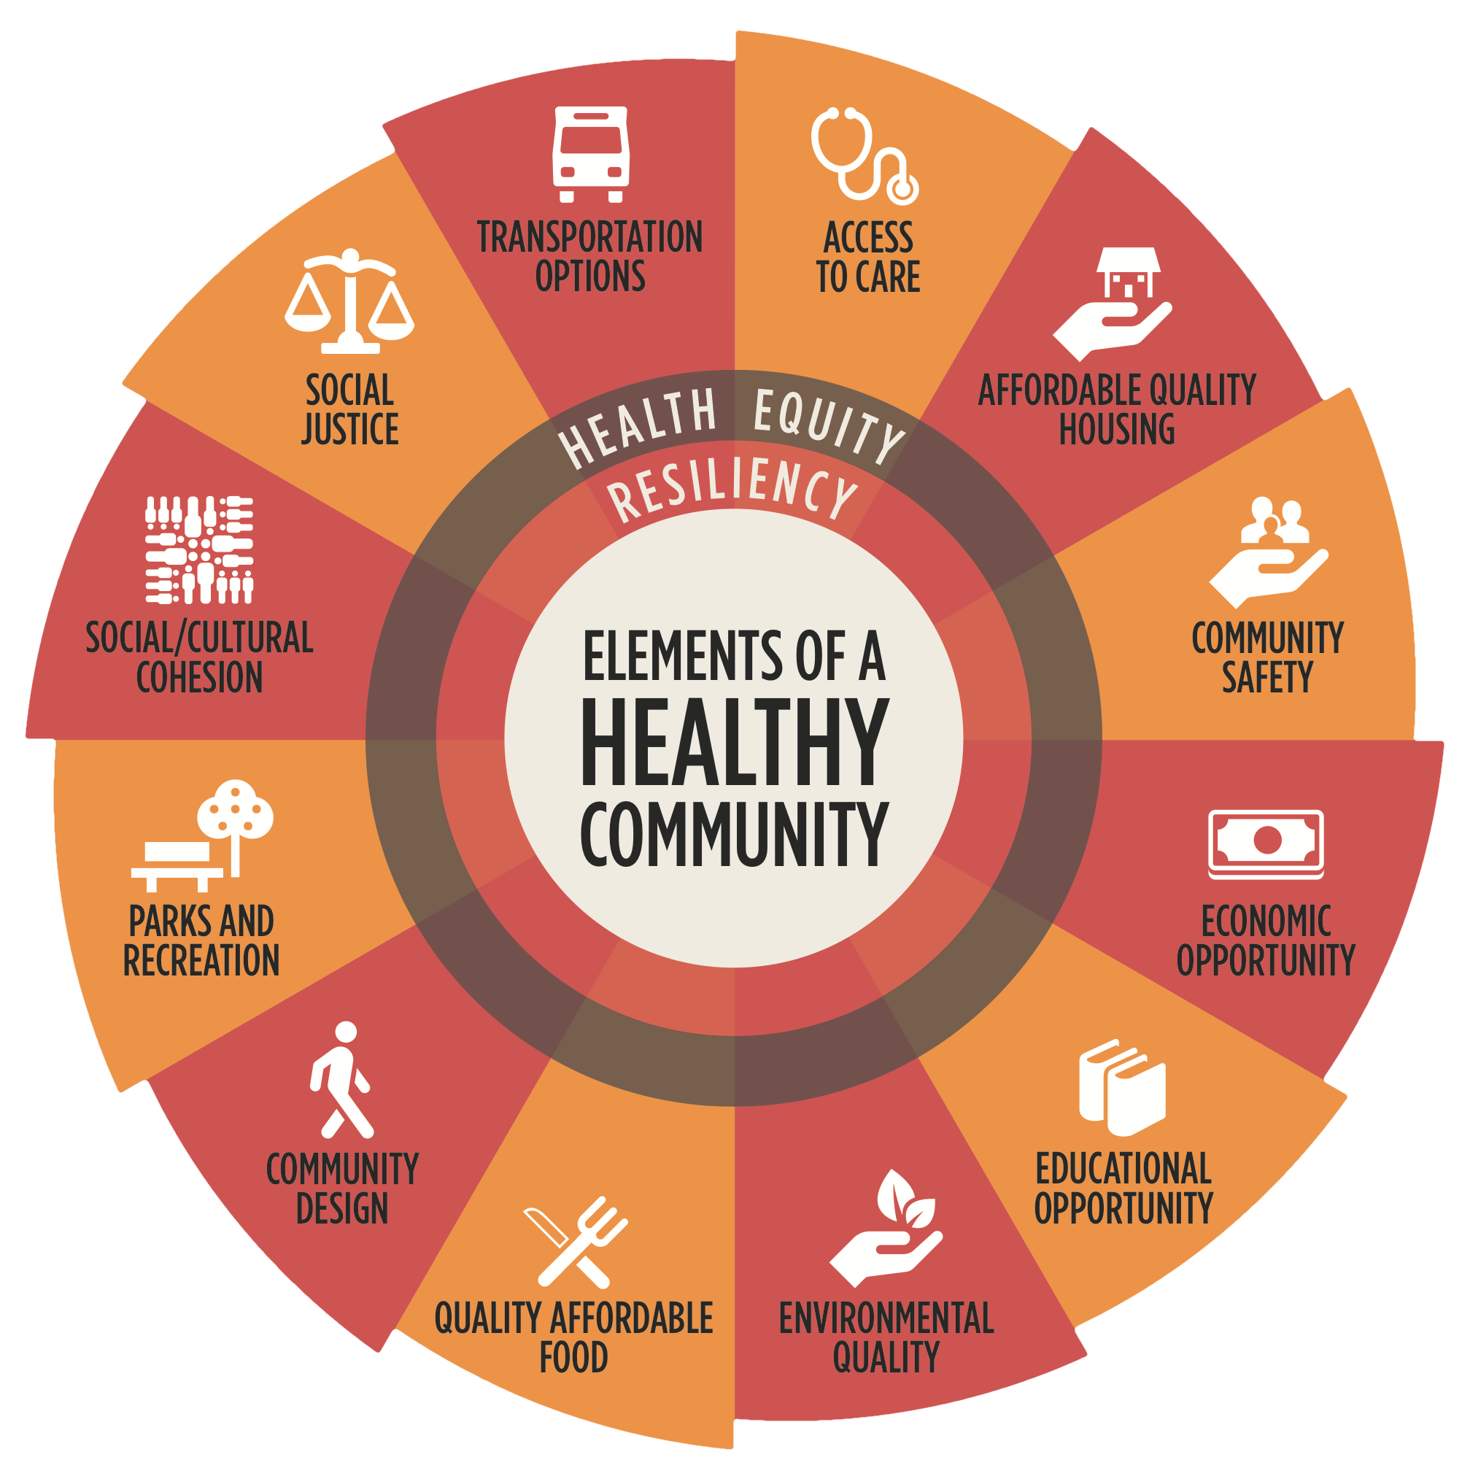
The Elements of a Healthy Community. Informed by the work of the World Health Organization, the Centers for Disease Control and Prevention, and community partners, Vitalyst developed the Elements of Healthy Community wheel in 2016 to identify and demonstrate the interrelated nature of 14 community factors that impact health. The wheel has become our model for integrating partners into the process of realizing improved well-being and health for all Arizonans. Learn more about the Elements at livewellaz.org
Connect and Learn More. Access information about our goals, publications, events, staff, trustees and more at vitalysthealth.org

